Use Case Specification
{{Project Name (CODE)}} – Report 3

Version | {{VERSION}}
Date | {{DATE}}

Change Log
Version | Date | Author | Summary
1.0 | {{DATE}} | {{AUTHOR}} | Initial draft

Table of Contents
Change Log 1
Table of Contents 2
Glossary 3
Conventions & Notation 3
Entity State Machines 3
{{ENTITY_1}} status workflow: 3
{{ENTITY_2}} status workflow: 3
Step Notation 3
UC Types at a Glance 4
Verification Criteria Format 4
UC-01: {{UC_01_NAME}} 4
Main Flow 5
Alternative Flows 5
Business Rules 5
Request Fields — {{UC_01_REQUEST_DTO}} 5
Allowed Roles 6
Verification Criteria 6
UC-02: {{UC_02_NAME}} 6
Main Flow 6
Alternative Flows 7
Business Rules 7
Request Fields — {{UC_02_REQUEST_DTO}} 7
Allowed Roles 7
Verification Criteria 7
UC-03: {{UC_03_NAME}} 7
UC-NN: {{UC_NN_NAME}} (API-type) 8
Endpoint 8
Main Flow 8
Alternative Flows 9
Business Rules 9
Data Payload — {{UC_NN_REQUEST_DTO}} 9
Allowed Callers 10
Verification Criteria 10

Glossary
Guidance
Define domain terms a developer who knows technology but not this business domain might misunderstand. Focus on: terms with multiple meanings, abbreviations, domain concepts that differ from everyday meaning.

Term | Definition
{{TERM_1}} | {{DEFINITION_1}}
{{TERM_2}} | {{DEFINITION_2}}
{{TERM_3}} | {{DEFINITION_3}}

Conventions & Notation

Entity State Machines
Critical
Draw ALL state machines before writing any UC block. Every status value in any AF or BR must appear in a state machine. Every transition must name the actor and UC that triggers it. Terminal states must be marked explicitly — no transitions out.

{{ENTITY_1}} status workflow:
{{ENTITY_1_STATE_MACHINE}}
Example: DRAFT → ACTIVE (HR Manager, UC-08: Publish) · ACTIVE → CLOSED (HR Manager, UC-08: Close) · [CLOSED — terminal]

{{ENTITY_2}} status workflow:
{{ENTITY_2_STATE_MACHINE}}
Example: APPLIED → SCREENING → INTERVIEW → OFFER → HIRED [terminal] · Any stage → REJECTED [terminal] · APPLIED/SCREENING → WITHDRAWN [terminal, Candidate-initiated]

Step Notation
Symbol | Meaning
[U] | The person takes an action (clicks, fills in, submits)
[S] | The system takes an action (checks, saves, sends, calculates)
[E] | The external system takes an action (sends data, requests information)
[J] | The scheduled process runs (triggered by time or event)
AF-xx | Alternative Flow — what happens when the main flow deviates
BR-xx | Business Rule — a condition or constraint the system must enforce

UC Types at a Glance
Aspect | UI-type | API-type | JOB-type
Who starts it | A person using a screen | An external system sending data | A schedule or internal event
Who can access | Named roles from PRD §2 | Authenticated external systems | Internal only — no external access
What it receives | Form input from a screen | A structured data payload | A trigger signal or event data
What it returns | A screen, message, or updated view | A structured response (success or failure) | No response — outcome is a side effect
Auth details | See TDS §4 | See TDS §4 | Not applicable

Verification Criteria Format
Good example
Given a candidate account exists with username 'john' and status ACTIVE When the candidate submits an application for Job ID 5 (status ACTIVE) Then a new application record exists with status APPLIED AND the candidate sees a confirmation message AND the job's application count increases by 1

Bad example
Given a candidate is logged in When they apply for a job Then it works

UC-01: View Warehouse List
UI-type block
Copy this block for each UI-type use case. Sections: Header | Main Flow | Alternative Flows | Business Rules | Request Fields | Allowed Roles | Verification Criteria
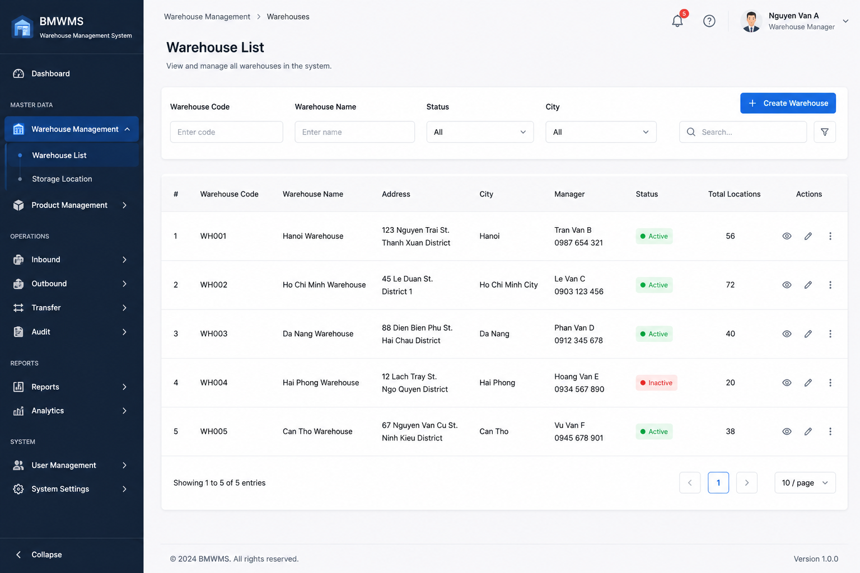

Field | Value
Type | UI
Primary Actor | Warehouse Manager
Secondary Actor(s) | Warehouse Staff
Module | Warehouse Management
FT-ID Ref | F01.01
Depends On | —
Preconditions | User is logged into the system and has permission to access Warehouse Management.
Postconditions | Warehouse list is displayed according to search and filter conditions.

Main Flow
- [U] User opens the Warehouse List screen.
- [S] System retrieves all warehouses available to the user.
- [S] System displays warehouse information including Warehouse Code, Warehouse Name, Address, City, Manager, Status and Total Locations.
- [U] User enters search criteria or selects filter conditions.
- [S] System validates filter values and executes search — see BR-01, BR-02.
- [S] System refreshes the warehouse list and displays matching records.
- [U] User navigates through pages or changes page size.
- [S] System displays the corresponding warehouse records.

Alternative Flows
AF-01 — No Matching Warehouse
At step 5, no warehouse satisfies the search criteria.
The system displays an empty result set with the message:
"No warehouse found."
AF-02 — Invalid Filter Value
At step 5, the user enters an unsupported filter value.
The system ignores the invalid filter and displays a validation message.
AF-03 — No Warehouse Available
At step 2, no warehouse records exist in the system.
The system displays an empty warehouse list and allows the user to create a new warehouse.

Business Rules
BR-01

The system shall support filtering by Warehouse Code.

BR-02

The system shall support filtering by Warehouse Name, Status and City.

BR-03

The warehouse list shall be displayed in paginated format.

BR-04

Inactive warehouses shall remain visible in the list.

BR-05

Only warehouses accessible to the logged-in user shall be displayed.

Request Fields — Warehouse Search Criteria
Field | Type | Rule
Warehouse Code | Text | Optional. Partial matching allowed.
Warehouse Name | Text | Optional. Partial matching allowed.
Status | Text | Optional. Active, Inactive or All.
City | Text | Optional. Select from available cities.
Search Keyword | Text | Optional. Searches Warehouse Code and Warehouse Name.
Page Number | Number | Optional. Default value is 1.
Page Size | Number | Optional. Default value is 10.

On success: The warehouse list is refreshed and displays all matching warehouse records.

Allowed Roles
- Warehouse Manager
- Warehouse Staff
- System Administrator

Verification Criteria
Given
- Warehouse records exist in the system
- The user has permission to access Warehouse Management
When
- The user opens the Warehouse List screen
- Or applies search and filter criteria
Then
- The system displays matching warehouse records
- And pagination information is displayed correctly
- And inactive warehouses are clearly identified

Additional scenarios to cover in tests:
- Search warehouse by Warehouse Code.
- Filter warehouse by Status = Active.
- Filter warehouse by City.
- Search returns no result.
- Navigate between pages.
- Change page size from 10 to 20 records.

UC-02: Create Warehouse
UI-type block
Copy this block for each UI-type use case. Sections: Header | Main Flow | Alternative Flows | Business Rules | Request Fields | Allowed Roles | Verification Criteria
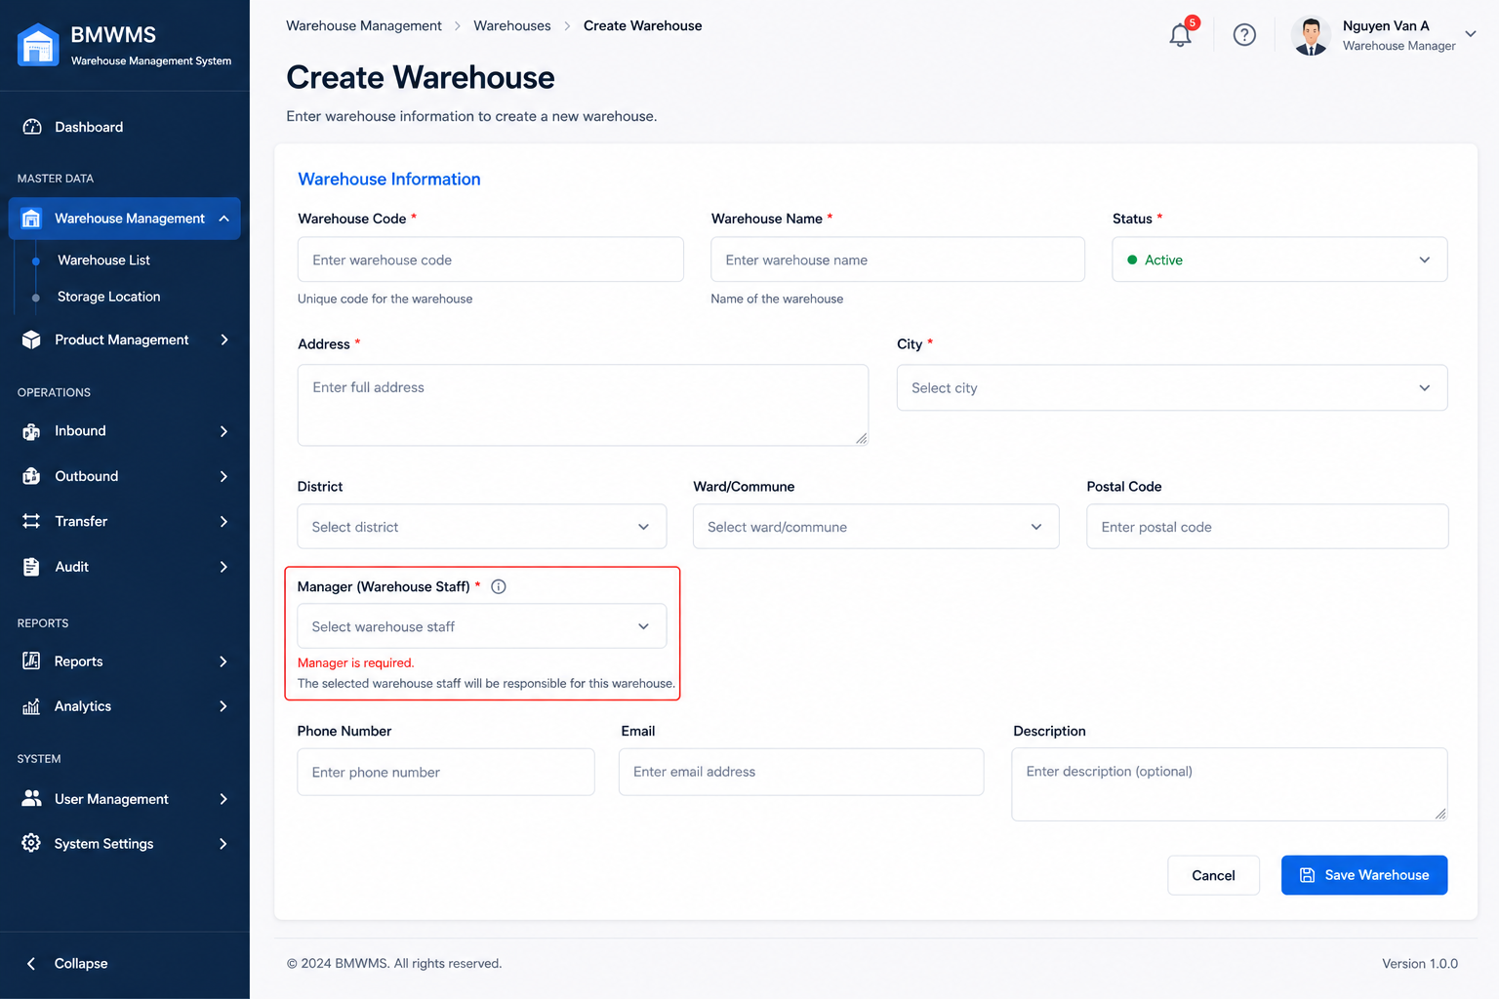

Field | Value
Type | UI
Primary Actor | Warehouse Manager
Secondary Actor(s) | System Administrator
Module | Warehouse Management
FT-ID Ref | F01.01
Depends On | —
Preconditions | User is logged in and has permission to create warehouses.
Postconditions | A new warehouse is created and available for warehouse operations.

Main Flow
- [U] User clicks Create Warehouse on the Warehouse List screen.
- [S] System displays the Create Warehouse form.
- [U] User enters warehouse information and submits the form.
- [S] System validates the input — see BR-01, BR-02, BR-03.
- [S] System creates a new Warehouse record with status Active.
- [S] System records the creator and creation timestamp.
- [S] System displays a success message.
- [S] System redirects the user to the Warehouse Detail screen.

Alternative Flows
AF-01 — Duplicate Warehouse Code
At step 4, the system finds that the Warehouse Code already exists.
The warehouse is not created.
The user remains on the form and sees:
"Warehouse Code already exists."
AF-02 — Required Information Missing
At step 4, one or more mandatory fields are empty.
The warehouse is not created.
The system highlights invalid fields and displays validation messages.
AF-03 — User Cancels Creation
At step 3, the user selects Cancel.
The system discards unsaved changes and returns to the Warehouse List screen.

Business Rules
BR-01

Warehouse Code must be unique across the entire system.

BR-02

Warehouse Code and Warehouse Name are mandatory.

BR-03

Warehouse Name must not exceed 255 characters.

BR-04

New warehouses are created with status Active by default.

BR-05

A warehouse manager may be assigned during warehouse creation.

BR-06

The system shall record creation date and creator information automatically.

Request Fields — Warehouse Search Criteria
Field | Type | Rule
Warehouse Code | Text | Required. Unique. Maximum 50 characters.
Warehouse Name | Text | Required. Maximum 255 characters.
Address | Text | Required. Maximum 500 characters.
City | Text | Required. Select from available cities.
Warehouse Manager | Text | Optional. Must be an active user.
Contact Phone | Text | Optional. Valid phone number format.
Description | Text | Optional. Maximum 1000 characters.
Status | Yes/No | Default Active.

On success: The warehouse is created successfully and the user is redirected to the Warehouse Detail screen.

Allowed Roles
- Warehouse Manager
- System Administrator

Verification Criteria
Given
- The user is logged in
- The user has warehouse creation permission
When
- The user submits valid warehouse information
Then
- A new warehouse record is created
- And the warehouse status is Active
- And creator information is recorded
- And the warehouse appears in the Warehouse List

Additional scenarios to cover in tests:
- Create warehouse with valid information.
- Create warehouse using an existing Warehouse Code.
- Submit form with missing required fields.
- Submit form with Warehouse Name exceeding maximum length.
- Cancel warehouse creation before saving.
- Verify warehouse appears in Warehouse List after creation.

UC-03: Update Warehouse
UI-type block
Copy this block for each UI-type use case. Sections: Header | Main Flow | Alternative Flows | Business Rules | Request Fields | Allowed Roles | Verification Criteria
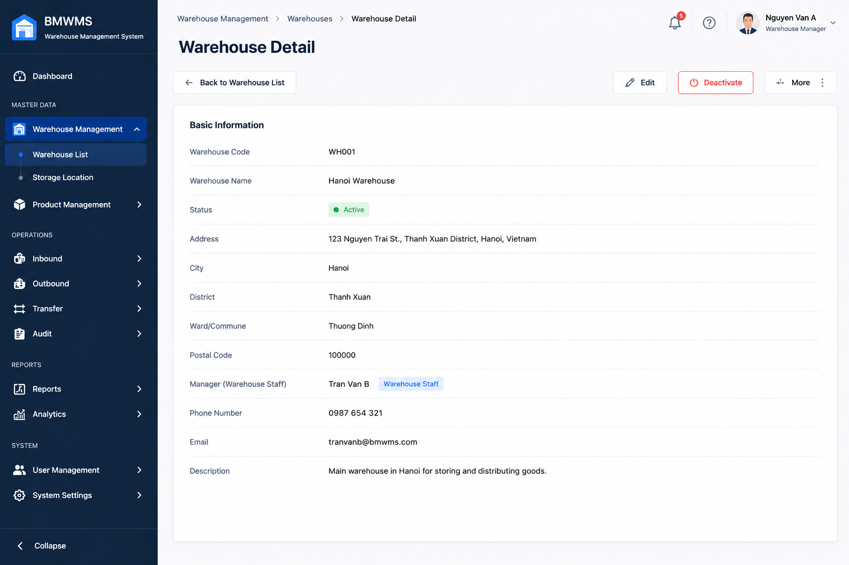

Field | Value
Type | UI
Primary Actor | Warehouse Manager
Secondary Actor(s) | System Administrator
Module | Warehouse Management
FT-ID Ref | F01.01
Depends On | UC-01 Create Warehouse
Preconditions | User is logged in and has warehouse update permission. The warehouse already exists.
Postconditions | Warehouse information is updated successfully.

Main Flow
- [U] User selects a warehouse from the Warehouse List.
- [U] User clicks the Edit button.
- [S] System displays the Warehouse Edit form with current warehouse information.
- [U] User modifies warehouse information.
- [U] User clicks Save.
- [S] System validates the input — see BR-01, BR-02, BR-03.
- [S] System updates the Warehouse record.
- [S] System records modification date and modifier information.
- [S] System displays a success message.
- [S] System refreshes warehouse information on the Warehouse Detail screen.

Alternative Flows
AF-01 — Warehouse Not Found
At step 3, the selected warehouse no longer exists.
The system displays:
"Warehouse not found."
The user is redirected to the Warehouse List screen.
AF-02 — Duplicate Warehouse Code
At step 6, the updated Warehouse Code already belongs to another warehouse.
The warehouse is not updated.
The user remains on the form and sees:
"Warehouse Code already exists."
AF-03 — Invalid Information
At step 6, one or more fields fail validation.
The warehouse is not updated.
The system highlights invalid fields and displays validation messages.
AF-04 — User Cancels Update
At step 4, the user clicks Cancel.
The system discards all unsaved changes and returns to the Warehouse Detail screen.

Business Rules
BR-01

Warehouse Code must remain unique across the system.

BR-02

Warehouse Name cannot be empty.

BR-03

Only Active users can be assigned as Warehouse Manager.

BR-04

Warehouse Code cannot be changed if inventory transactions already exist for the warehouse.

BR-05

All warehouse update activities must be recorded in the audit log.

BR-06

The system shall automatically update Last Modified Date and Last Modified By.

Request Fields — Warehouse Search Criteria
Field | Type | Rule
Warehouse Code | Text | Required. Unique. Read-only if inventory transactions exist.
Warehouse Name | Text | Required. Maximum 255 characters.
Address | Text | Required. Maximum 500 characters.
City | Text | Required. Select from available cities.
Warehouse Manager | Text | Optional. Must be an active user.
Contact Phone | Text | Optional. Valid phone number format.
Description | Text | Optional. Maximum 1000 characters.
Status | Yes/No | Active or Inactive.

On success: The warehouse information is updated successfully and the latest information is displayed.

Allowed Roles
- Warehouse Manager
- System Administrator

Verification Criteria
Given
- The user is logged in
- The warehouse exists
- The user has warehouse update permission
When
- The user submits valid warehouse changes
Then
- The warehouse record is updated
- And modification information is recorded
- And updated information is displayed immediately

Additional scenarios to cover in tests:

- Update warehouse name successfully.
- Update warehouse address successfully.
- Assign a new warehouse manager.
- Update using an existing Warehouse Code.
- Attempt to assign an inactive user as manager.
- Cancel update without saving.
- Verify audit log is created after update.
- Verify Last Modified Date is updated correctly.

UC-04: View Warehouse Detail
UI-type block
Copy this block for each UI-type use case. Sections: Header | Main Flow | Alternative Flows | Business Rules | Request Fields | Allowed Roles | Verification Criteria


Field | Value
Type | UI
Primary Actor | Warehouse Manager
Secondary Actor(s) | Warehouse Staff, System Administrator
Module | Warehouse Management
FT-ID Ref | F01.01
Depends On | UC-01 View Warehouse List
Preconditions | User is logged in and has warehouse viewing permission. Warehouse exists in the system.
Postconditions | Warehouse detail information is displayed.

Main Flow
- [U] User accesses the Warehouse List screen.
- [U] User selects a warehouse.
- [U] User clicks the View button.
- [S] System retrieves warehouse information.
- [S] System retrieves related storage location information.
- [S] System retrieves current inventory summary for the warehouse.
- [S] System displays Warehouse Detail information.
- [S] System displays storage location statistics and inventory summary.

Alternative Flows
AF-01 — Warehouse Not Found
At step 4, the selected warehouse no longer exists.
The system displays:
"Warehouse not found."
The user is redirected to the Warehouse List screen.
AF-02 — User Has No Permission
At step 3, the user does not have permission to view warehouse details.
The system displays:
"You do not have permission to access this warehouse."
AF-03 — No Storage Locations
At step 5, no storage locations exist for the warehouse.
The system displays warehouse information and shows:
"No storage locations available."
AF-04 — No Inventory Available
At step 6, the warehouse contains no inventory.
The system displays inventory summary with zero values.

Business Rules
BR-01
Users can only view warehouses they are authorized to access.

BR-02
Warehouse information displayed must reflect the latest saved data.

BR-03
Inventory statistics must be calculated in real time.

BR-04
Inactive warehouses remain viewable for audit and reporting purposes.

BR-05
Warehouse detail information is read-only on the View screen.

Request Fields — Warehouse Detail Request
Field | Type | Rule
Warehouse ID | Number | Required. Must exist in the system.
Warehouse Code | Text | Display only.
Warehouse Name | Text | Display only.
Address | Text | Display only.
City | Text | Display only.
Warehouse Manager | Text | Display only.
Contact Phone | Text | Display only.
Status | Text | Active or Inactive.
Created Date | Date | Display only.
Last Modified Date | Date | Display only.
Total Storage Locations | Number | Calculated by system.
Total Inventory Quantity | Number | Calculated by system.
Description | Text | Display only.

On success: Warehouse detail information, storage location statistics, and inventory summary are displayed.

Allowed Roles
- Warehouse Manager
- Warehouse Staff
- System Administrator
- Purchasing Staff (View Only)
- Sales Staff (View Only)

Verification Criteria
Given
- The user is logged in
- The warehouse exists
- The user has viewing permission
When
- The user selects a warehouse and clicks View
Then
- Warehouse details are displayed
- Storage location statistics are displayed
- Inventory summary is displayed

Additional scenarios to cover in tests:

- View an active warehouse.
- View an inactive warehouse.
- View warehouse with storage locations.
- View warehouse without storage locations.
- View warehouse with inventory.
- View warehouse without inventory.
- Attempt to view a warehouse without permission.
- Attempt to view a deleted or non-existing warehouse.
- Verify inventory summary values are correct.
- Verify storage location totals are correct.

UC-05: Deactivate Warehouse
UI-type block
Copy this block for each UI-type use case. Sections: Header | Main Flow | Alternative Flows | Business Rules | Request Fields | Allowed Roles | Verification Criteria
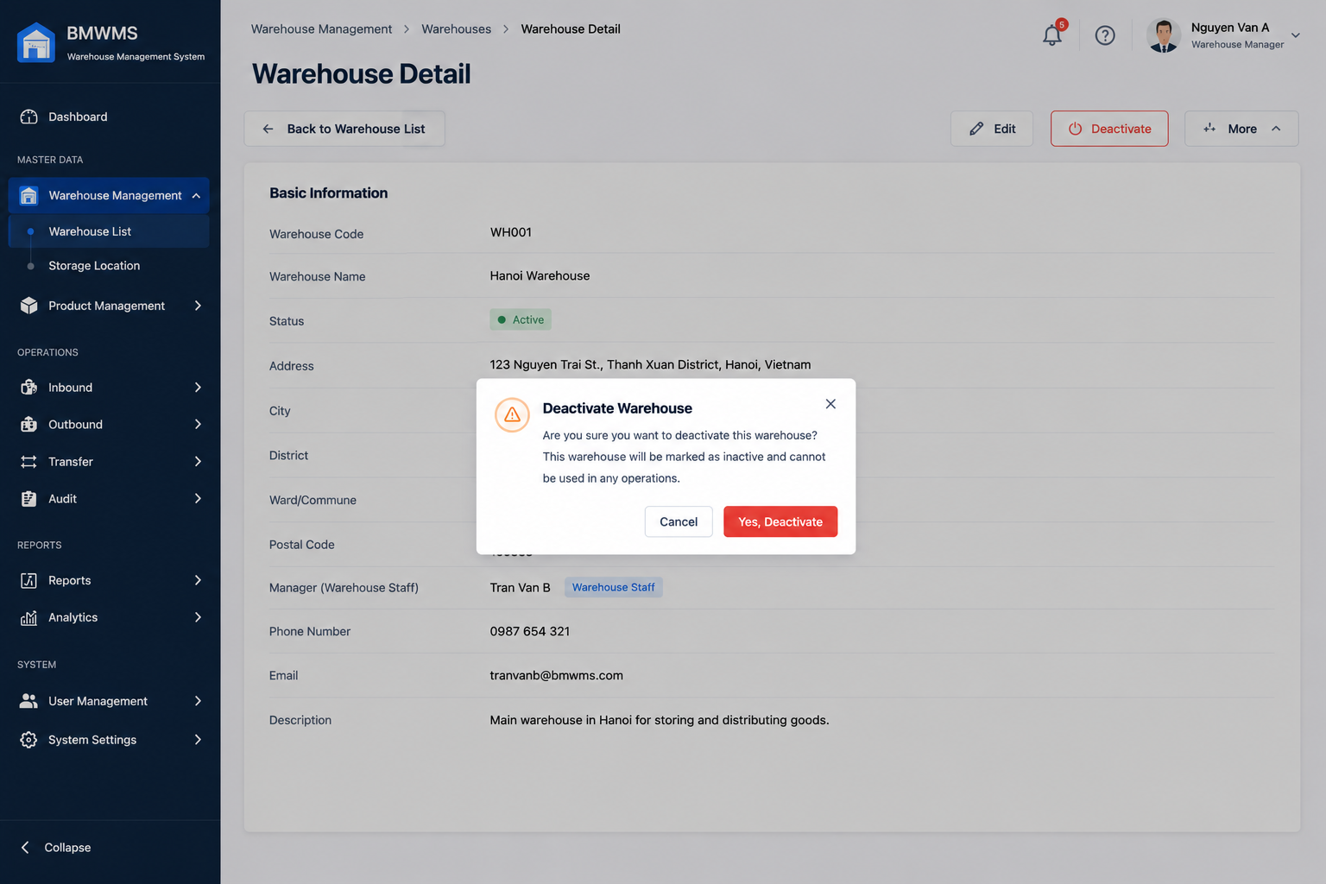

Field | Value
Type | UI
Primary Actor | Warehouse Manager
Secondary Actor(s) | System Administrator
Module | Warehouse Management
FT-ID Ref | F01.01
Depends On | UC-01 View Warehouse List
Preconditions | User is logged in. User has warehouse management permission. Warehouse exists and is currently Active.
Postconditions | Warehouse status is changed from Active to Inactive. Warehouse is no longer available for new warehouse operations.

Main Flow
- [U] User accesses the Warehouse List screen.
- [U] User selects an active warehouse.
- [U] User clicks the Deactivate action.
- [S] System displays a confirmation dialog.
- [U] User confirms the deactivation.
- [S] System validates warehouse status — see BR-01, BR-02.
- [S] System changes the warehouse status to Inactive.
- [S] System records the deactivation activity in the audit log.
- [S] System displays a success message.
- [S] System refreshes the Warehouse List.

Alternative Flows
AF-01 — User Cancels Action
At step 5, the user selects Cancel.
The system closes the confirmation dialog.
No changes are made.
AF-02 — Warehouse Already Inactive
At step 6, the warehouse status is already Inactive.
The system displays:
"Warehouse is already inactive."
No changes are made.
AF-03 — Warehouse Contains Active Transactions
At step 6, the warehouse is referenced by pending inbound, outbound, transfer, or stocktaking transactions.
The system displays:
"Warehouse cannot be deactivated because active transactions exist."
No changes are made.
AF-04 — Insufficient Permission
At step 3, the user does not have deactivation permission.
The system displays:
"You do not have permission to deactivate this warehouse."

Business Rules
BR-01
Only Active warehouses can be deactivated.

BR-02
A warehouse with pending operational transactions cannot be deactivated.

BR-03
Deactivation changes warehouse status only; warehouse data is retained.

BR-04
Inactive warehouses cannot be selected when creating inbound, outbound, transfer, or stocktaking transactions.

BR-05
All warehouse deactivation activities must be recorded in the audit log.

BR-06
Only Warehouse Managers and System Administrators may deactivate warehouses.

Request Fields — Warehouse Detail Request
Field | Type | Rule
Warehouse ID | Number | Required. Must exist in the system.
Confirmation | Yes/No | Must be Yes to proceed.
Deactivation Reason | Text | Optional. Maximum 500 characters.

Response Fields
Field | Type | Rule
Warehouse ID | Number | Display only.
Warehouse Code | Text | Display only.
Warehouse Name | Text | Display only.
Previous Status | Text | Active.
New Status | Text | Inactive.
Deactivated By | Text | Current user.
Deactivated Date | Date | System generated.

On success: Warehouse status is updated to Inactive and the warehouse is removed from future operational selections.

Allowed Roles
- Warehouse Manager
- System Administrator

Verification Criteria
Given
- The user is logged in
- The warehouse exists
- The warehouse is Active
- No pending transactions exist
When
- The user confirms warehouse deactivation
Then
- Warehouse status becomes Inactive
- Audit log is created
- Success message is displayed

Additional scenarios to cover in tests:

- Deactivate a warehouse with no active transactions.
- Attempt to deactivate a warehouse with pending inbound orders.
- Attempt to deactivate a warehouse with pending outbound orders.
- Attempt to deactivate a warehouse with pending transfer requests.
- Cancel the deactivation confirmation.
- Attempt to deactivate an already inactive warehouse.
- Verify warehouse remains visible in historical reports.
- Verify inactive warehouse cannot be selected during transaction creation.
- Verify audit log is generated correctly.
- Verify unauthorized users cannot deactivate warehouses.

UC-06: View Storage Location List
UI-type block
Copy this block for each UI-type use case. Sections: Header | Main Flow | Alternative Flows | Business Rules | Request Fields | Allowed Roles | Verification Criteria
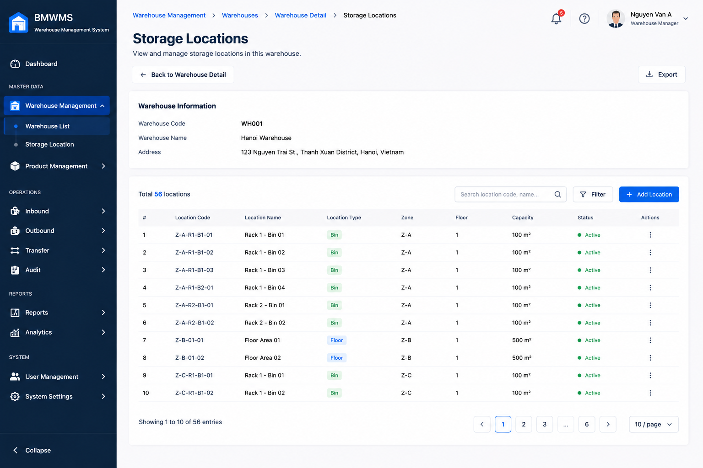

Field | Value
Type | UI
Primary Actor | Warehouse Manager
Secondary Actor(s) | Warehouse Staff, System Administrator
Module | Warehouse Management
FT-ID Ref | F01.02
Depends On | UC-04 View Warehouse Detail
Preconditions | User is logged in and has permission to access Storage Location Management. At least one warehouse exists.
Postconditions | Storage Location List is displayed according to selected warehouse and search criteria.

Main Flow
- [U] User navigates to a warehouse detail screen.
- [U] User opens the Storage Location tab or selects Storage Location Management.
- [S] System retrieves all storage locations belonging to the selected warehouse.
- [S] System displays storage location information including Location Code, Location Name, Location Type, Capacity, Utilization, and Status.
- [U] User enters search criteria or filter conditions.
- [S] System validates search conditions — see BR-01, BR-02.
- [S] System refreshes the storage location list.
- [S] System displays matching storage locations.
- [U] User navigates through pages or changes page size.
- [S] System displays the corresponding storage location records.

Alternative Flows
AF-01 — No Storage Locations Found
At step 7, no storage location matches the search criteria.
The system displays:
"No storage locations found."
AF-02 — Warehouse Has No Storage Locations
At step 3, the selected warehouse does not contain any storage locations.
The system displays an empty list and allows authorized users to create a new storage location.
AF-03 — Invalid Search Criteria
At step 6, one or more filter values are invalid.
The system displays a validation message and keeps the current search conditions.
AF-04 — Warehouse Not Found
At step 3, the selected warehouse no longer exists.
The system displays:
"Warehouse not found."
The user is redirected to the Warehouse List screen.

Business Rules
BR-01
The system shall support searching by Location Code.

BR-02
The system shall support filtering by Location Type and Status.

BR-03
Storage locations shall only be displayed within the selected warehouse.

BR-04
Inactive storage locations shall remain visible for audit and reporting purposes.

BR-05
Storage utilization percentage shall be calculated automatically based on current inventory quantity and configured capacity.

BR-06
The list shall support pagination.

Request Fields — Warehouse Detail Request
Field | Type | Rule
Warehouse ID | Number | Required. Must exist in the system.
Location Code | Text | Optional. Partial matching allowed.
Location Name | Text | Optional. Partial matching allowed.
Location Type | Text | Optional. Zone, Rack, Shelf, Bin or All.
Status | Text | Optional. Active, Inactive or All.
Search Keyword | Text | Optional. Searches Location Code and Location Name.
Page Number | Number | Optional. Default value is 1.
Page Size | Number | Optional. Default value is 10.

Response Fields
Field | Type | Rule
Location Code | Text | Display only.
Location Name | Text | Display only.
Location Type | Text | Display only.
Capacity | Number | Display only.
Current Utilization | Number | System calculated.
Utilization Percentage | Number | System calculated.
Status | Text | Active or Inactive.

On success: Matching storage locations are displayed together with capacity and utilization information.

Allowed Roles
- Warehouse Manager
- Warehouse Staff
- System Administrator
- Purchasing Staff (View Only)
- Sales Staff (View Only)

Verification Criteria
Given
- The user is logged in
- The selected warehouse exists
- The user has permission to view storage locations
When
- The user opens the Storage Location List screen
- Or applies search and filter criteria
Then
- Storage locations belonging to the selected warehouse are displayed
- Capacity information is displayed
- Utilization information is displayed
- Pagination works correctly

Additional scenarios to cover in tests:

- View storage locations of a warehouse.
- Search by Location Code.
- Search by Location Name.
- Filter by Location Type.
- Filter by Status.
- View a warehouse with no storage locations.
- Search with no matching records.
- Navigate through multiple pages.
- Verify utilization percentage calculation.
- Verify inactive locations are displayed correctly.

UC-07: Create Storage Location
UI-type block
Copy this block for each UI-type use case. Sections: Header | Main Flow | Alternative Flows | Business Rules | Request Fields | Allowed Roles | Verification Criteria


Field | Value
Type | UI
Primary Actor | Warehouse Manager
Secondary Actor(s) | System Administrator
Module | Warehouse Management
FT-ID Ref | F01.02
Depends On | UC-04 View Warehouse Detail
Preconditions | User is logged in and has permission to manage storage locations. Target warehouse exists and is active.
Postconditions | A new storage location is created and assigned to the selected warehouse.

Main Flow
- [U] User opens the Storage Location List screen of a warehouse.
- [U] User clicks Create Storage Location.
- [S] System displays the Create Storage Location form.
- [U] User enters storage location information.
- [U] User clicks Save.
- [S] System validates the input — see BR-01, BR-02, BR-03.
- [S] System creates a new Storage Location record.
- [S] System assigns the storage location to the selected warehouse.
- [S] System records creation date and creator information.
- [S] System displays a success message.
- [S] System refreshes the Storage Location List.

Alternative Flows
AF-01 — Duplicate Location Code
At step 6, the Location Code already exists within the selected warehouse.
The storage location is not created.
The user remains on the form and sees:
"Location Code already exists in this warehouse."
AF-02 — Required Information Missing
At step 6, one or more required fields are empty.
The storage location is not created.
The system highlights invalid fields and displays validation messages.
AF-03 — Capacity Value Invalid
At step 6, Capacity is less than or equal to zero.
The storage location is not created.
The system displays:
"Capacity must be greater than zero."
AF-04 — User Cancels Creation
At step 4, the user selects Cancel.
The system discards all unsaved information and returns to the Storage Location List screen.

Business Rules
BR-01
Location Code must be unique within a warehouse.

BR-02
Location Code, Location Name, and Location Type are required.

BR-03
Capacity must be greater than zero.

BR-04
New storage locations are created with status Active by default.

BR-05
A storage location must belong to exactly one warehouse.

BR-06
The system shall automatically record creation date and creator information.

Request Fields — Warehouse Detail Request
Field | Type | Rule
Warehouse | Text | Required. Must be an active warehouse.
Location Code | Text | Required. Unique within warehouse. Maximum 50 characters.
Location Name | Text | Required. Maximum 255 characters.
Location Type | Text | Required. Zone, Rack, Shelf, Bin.
Capacity | Number | Required. Must be greater than 0.
Description | Text | Optional. Maximum 1000 characters.
Status | Yes/No | Default Active.
On success: The storage location is created successfully and appears in the Storage Location List.

Allowed Roles
- Warehouse Manager
- System Administrator

Verification Criteria
Given
- The user is logged in
- The warehouse exists and is active
- The user has storage location management permission
When
- The user submits valid storage location information
Then
- A new storage location is created
- The location is assigned to the selected warehouse
- Status is Active
- The location appears in the Storage Location List

Additional scenarios to cover in tests:

- Create a Zone location successfully.
- Create a Rack location successfully.
- Create a Shelf location successfully.
- Create a Bin location successfully.
- Create a location with an existing Location Code.
- Create a location with invalid Capacity.
- Submit form with missing required fields.
- Cancel creation before saving.
- Verify creator information is recorded.
- Verify the new location appears in the correct warehouse.

UC-08: Update Storage Location
UI-type block
Copy this block for each UI-type use case. Sections: Header | Main Flow | Alternative Flows | Business Rules | Request Fields | Allowed Roles | Verification Criteria


Field | Value
Type | UI
Primary Actor | Warehouse Manager
Secondary Actor(s) | System Administrator
Module | Warehouse Management
FT-ID Ref | F01.02
Depends On | UC-06 View Storage Location List
Preconditions | User is logged in and has permission to manage storage locations. The storage location already exists.
Postconditions | Storage location information is updated successfully.

Main Flow
- [U] User accesses the Storage Location List screen.
- [U] User selects a storage location.
- [U] User clicks the Edit button.
- [S] System displays the Storage Location Edit form with current information.
- [U] User modifies storage location information.
- [U] User clicks Save.
- [S] System validates the input — see BR-01, BR-02, BR-03.
- [S] System updates the Storage Location record.
- [S] System records modification date and modifier information.
- [S] System displays a success message.
- [S] System refreshes the Storage Location Detail screen.

Alternative Flows
AF-01 — Storage Location Not Found
At step 4, the selected storage location no longer exists.
The system displays:
"Storage Location not found."
The user is redirected to the Storage Location List screen.
AF-02 — Duplicate Location Code
At step 7, the updated Location Code already exists within the same warehouse.
The storage location is not updated.
The user remains on the form and sees:
"Location Code already exists in this warehouse."
AF-03 — Invalid Capacity
At step 7, Capacity is less than the current utilized quantity.
The storage location is not updated.
The system displays:
"Capacity cannot be less than current utilized quantity."
AF-04 — User Cancels Update
At step 5, the user clicks Cancel.
The system discards all unsaved changes and returns to the Storage Location Detail screen.

Business Rules
BR-01
Location Code must remain unique within the warehouse.

BR-02
Location Code, Location Name, and Location Type are mandatory.

BR-03
Capacity must be greater than zero.

BR-04
Capacity cannot be smaller than the quantity currently stored in the location.

BR-05
Location Type cannot be changed if inventory already exists in the location.

BR-06
All update activities must be recorded in the audit log.

BR-07
The system shall automatically update Last Modified Date and Last Modified By.

Request Fields — Warehouse Detail Request
Field | Type | Rule
Location Code | Text | Required. Unique within warehouse. Maximum 50 characters.
Location Name | Text | Required. Maximum 255 characters.
Location Type | Text | Required. Zone, Rack, Shelf, Bin. Read-only if inventory exists.
Capacity | Number | Required. Greater than 0 and not less than current utilization.
Description | Text | Optional. Maximum 1000 characters.
Status | Yes/No | Active or Inactive.
On success: Storage location information is updated successfully and the latest information is displayed

Allowed Roles
- Warehouse Manager
- System Administrator

Verification Criteria
Given
- The user is logged in
- The storage location exists
- The user has storage location management permission
When
- The user submits valid updates
Then
- The storage location record is updated
- Modification information is recorded
- Updated information is displayed immediately
Additional scenarios to cover in tests:
- Update Location Name successfully.
- Update Capacity successfully.
- Update Description successfully.
- Update using a duplicate Location Code.
- Set Capacity smaller than current utilized quantity.
- Attempt to change Location Type when inventory exists.
- Cancel update without saving.
- Verify audit log creation.
- Verify Last Modified Date is updated correctly.
- Verify updated information appears in Storage Location List and Detail screens.

UC-09: View Storage Location Detail
UI-type block
Copy this block for each UI-type use case. Sections: Header | Main Flow | Alternative Flows | Business Rules | Request Fields | Allowed Roles | Verification Criteria


Field | Value
Type | UI
Primary Actor | Warehouse Manager
Secondary Actor(s) | Warehouse Staff, System Administrator
Module | Warehouse Management
FT-ID Ref | F01.02
Depends On | UC-06 View Storage Location List
Preconditions | User is logged in and has permission to view storage location information. Storage Location exists in the system.
Postconditions | Storage Location detail information is displayed.

Main Flow
- [U] User accesses the Storage Location List screen.
- [U] User selects a storage location.
- [U] User clicks the View button.
- [S] System retrieves storage location information.
- [S] System retrieves warehouse information associated with the location.
- [S] System retrieves current inventory information stored at the location.
- [S] System calculates utilization statistics.
- [S] System displays Storage Location Detail information.
- [S] System displays inventory summary and utilization information.

Alternative Flows
AF-01 — Storage Location Not Found
At step 4, the selected storage location no longer exists.
The system displays:
"Storage Location not found."
The user is redirected to the Storage Location List screen.
AF-02 — No Inventory Stored
At step 6, no inventory exists in the selected location.
The system displays:
"No inventory currently stored."
Inventory statistics are displayed as zero.
AF-03 — User Has No Permission
At step 3, the user does not have permission to view storage location details.
The system displays:
"You do not have permission to access this storage location."
AF-04 — Warehouse Information Unavailable
At step 5, warehouse information cannot be retrieved.
The system displays the storage location information and indicates warehouse information is unavailable.

Business Rules
BR-01
Users can only view storage locations they are authorized to access.

BR-02
Storage location information displayed must reflect the latest saved data.

BR-03
Utilization percentage must be calculated based on current inventory quantity and configured capacity.

BR-04
Inactive storage locations remain viewable for audit and reporting purposes.

BR-05
Storage Location Detail is a read-only screen.

BR-06
Inventory information displayed must be updated in real time.

Request Fields — Storage Location Detail Request
Field | Type | Rule
Storage Location ID | Number | Required. Must exist in the system.

Response Fields
Field | Type | Rule
Location Code | Text | Display only.
Location Name | Text | Display only.
Location Type | Text | Display only.
Warehouse | Text | Display only.
Capacity | Number | Display only.
Current Utilization | Number | System calculated.
Utilization Percentage | Number | System calculated.
Status | Text | Active or Inactive.
Created Date | Date | Display only.
Last Modified Date | Date | Display only.
Description | Text | Display only.
On success: Storage location details, inventory summary, and utilization information are displayed.

Allowed Roles
- Warehouse Manager
- Warehouse Staff
- System Administrator
- Purchasing Staff (View Only)
- Sales Staff (View Only)

Verification Criteria
Given
- The user is logged in
- The storage location exists
- The user has viewing permission
When
- The user selects a storage location and clicks View
Then
- Storage location details are displayed
- Warehouse information is displayed
- Inventory summary is displayed
- Utilization statistics are displayed
Additional scenarios to cover in tests:
- View an active storage location.
- View an inactive storage location.
- View a storage location containing inventory.
- View a storage location with no inventory.
- Verify utilization percentage calculation.
- Verify capacity information is displayed correctly.
- Attempt to view a non-existing storage location.
- Attempt to view without permission.
- Verify inventory information is updated correctly.
- Verify warehouse information is displayed correctly.

UC-10: Locate Product
UI-type block
Copy this block for each UI-type use case. Sections: Header | Main Flow | Alternative Flows | Business Rules | Request Fields | Allowed Roles | Verification Criteria

Field | Value
Type
Primary Actor
Secondary Actor(s)
Module
FT-ID Ref
Depends On
Preconditions
Postconditions

Main Flow

Alternative Flows

Business Rules

Request Fields — Storage Location Detail Request
Field | Type | Rule

Response Fields
Field | Type | Rule
On success: Storage location details, inventory summary, and utilization information are displayed.

Allowed Roles

Verification Criteria

Additional scenarios to cover in tests:

UC-11: View Product List
UI-type block
Copy this block for each UI-type use case. Sections: Header | Main Flow | Alternative Flows | Business Rules | Request Fields | Allowed Roles | Verification Criteria
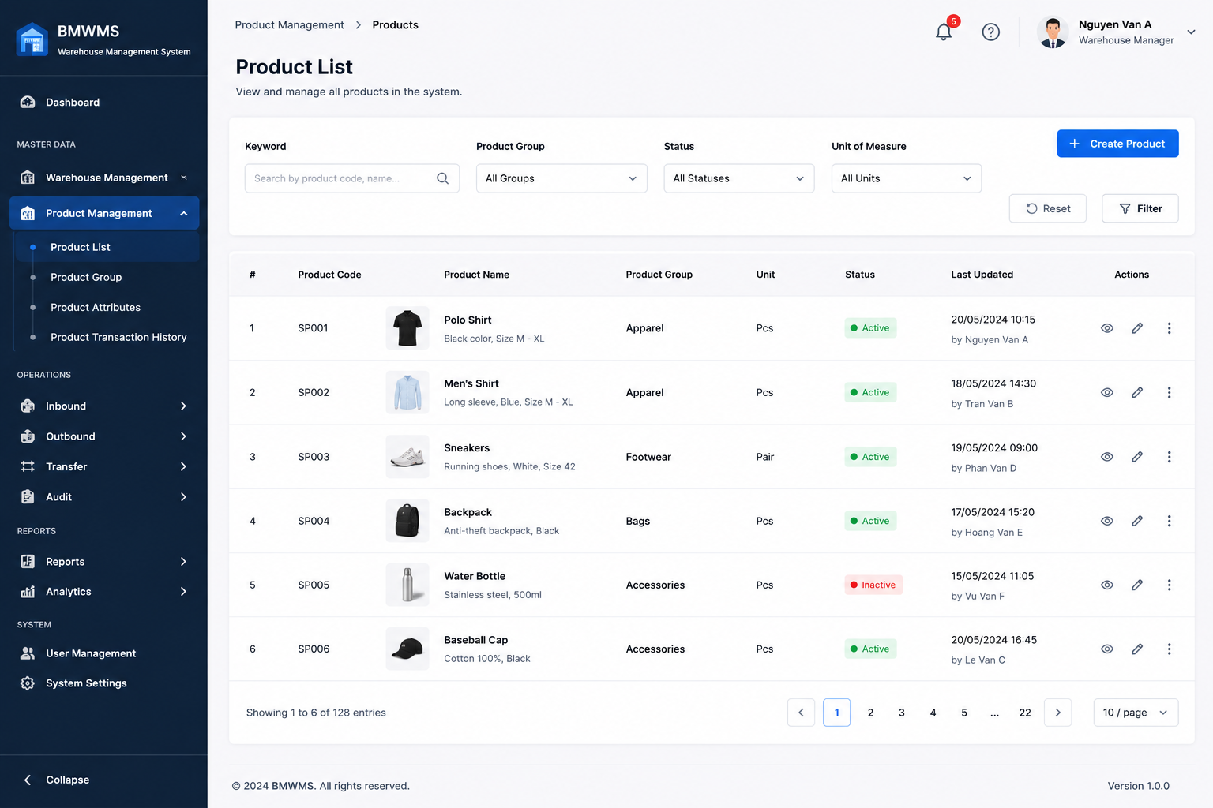

Field | Value
Type | UI
Primary Actor | Warehouse Manager
Secondary Actor(s) | Warehouse Staff, Purchasing Staff, Sales Staff
Module | Product Management
FT-ID Ref | F02.01
Depends On | —
Preconditions | User is logged in and has permission to access Product Management.
Postconditions | Product list is displayed according to search and filter criteria.

Main Flow
- [U] User opens the Product List screen.
- [S] System retrieves product records.
- [S] System displays product information including Product Code, Product Name, Product Group, Unit of Measure, Status, and Inventory Quantity.
- [U] User enters search criteria or filter conditions.
- [S] System validates search conditions — see BR-01, BR-02.
- [S] System searches matching product records.
- [S] System refreshes the product list.
- [S] System displays matching products.
- [U] User navigates through pages or changes page size.
- [S] System displays the corresponding product records.

Alternative Flows
AF-01 — No Matching Products
At step 6, no product matches the search criteria.
The system displays:
"No products found."
AF-02 — No Products Available
At step 2, no products exist in the system.
The system displays an empty product list and allows authorized users to create products.
AF-03 — Invalid Search Criteria
At step 5, invalid filter values are entered.
The system displays validation messages and retains current search criteria.
AF-04 — Unauthorized Access
At step 1, the user does not have permission to access Product Management.
The system displays:
"Access denied."

Business Rules
BR-01
The system shall support searching by Product Code.

BR-02
The system shall support searching by Product Name.

BR-03
The system shall support filtering by Product Group.

BR-04
The system shall support filtering by Product Status.

BR-05
Both Active and Inactive products shall remain searchable.

BR-06
Product inventory quantity displayed shall reflect the latest inventory status.

BR-07
The product list shall support pagination.

Request Fields — Storage Location Detail Request
Field | Type | Rule
Product Code | Text | Optional. Partial matching allowed.
Product Name | Text | Optional. Partial matching allowed.
Product Group | Text | Optional. Filter by product group.
Status | Text | Optional. Active, Inactive or All.
Search Keyword | Text | Optional. Searches Product Code and Product Name.
Page Number | Number | Optional. Default value is 1.
Page Size | Number | Optional. Default value is 10.

Response Fields
Field | Type | Rule
Product Code | Text | Display only.
Product Name | Text | Display only.
Product Group | Text | Display only.
Unit of Measure | Text | Display only.
Inventory Quantity | Number | System calculated.
Status | Text | Active or Inactive.
Last Updated | Date | Display only.
On success: The system displays matching product records and associated inventory information.

Allowed Roles
- Warehouse Manager
- Warehouse Staff
- System Administrator
- Purchasing Staff
- Sales Staff

Verification Criteria
Given
- The user is logged in
- Product records exist in the system
- The user has product viewing permission
When
- The user opens the Product List screen
- Or performs a search
Then
- Matching product records are displayed
- Product information is displayed correctly
- Pagination works correctly

Additional scenarios to cover in tests:
- View Product List.
- Search by Product Code.
- Search by Product Name.
- Filter by Product Group.
- Filter by Product Status.
- Search returns no results.
- View inactive products.
- Navigate between pages.
- Change page size.
- Verify inventory quantities are displayed correctly.
- Verify users without permission cannot access the screen.

